**Travel Management System**

**Introduction:**

Travel Management System is simple software lets you to book your bus tickets in prior to your travel.

**Modules in Travel Management System:**

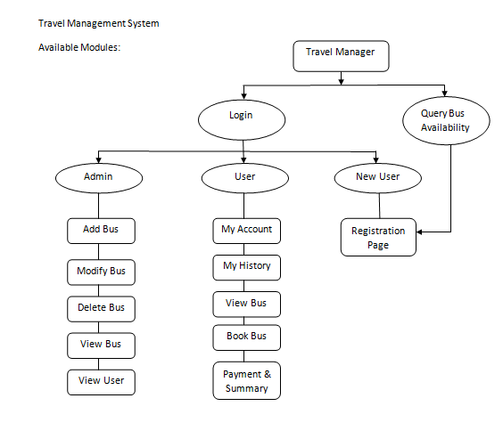

**Home:**

When a user selects travel manager, he will be allowed to view the list of available buses or he can login to the system using his credentials. Initially user cannot book the bus immediately after viewing the available buses. User should be authenticated to book the bus i.e., user should be logged in using his credentials. If new user is requested for booking the bus, user should be registered in our system using Registration page.

**User login:**

Similar to other management systems, our travel manager also has two types of users based on the login.

1. Admin user: User can add, modify, delete bus details and can manage the list of other users
2. Registered user: User can view, book or cancel the booked seat in bus. This user can also view his travel history done through the Travel Manager.
3. Spectators: User who can only view the list of available buses on the specified date and time. This user cannot book the bus. If required, have to register as a new user then he will be allowed to book the bus tickets.

**List of Planned modules:**

1. Admin User: The following Pages are allowed to be used by Admin user.
   1. Add Bus
   2. Modify Bus
   3. Delete Bus
   4. View Bus
   5. View User
2. Registered User
   1. My Accounts
   2. My Travel History
   3. View Bus
   4. Book Bus
   5. Payment & Summary
3. Spectators:
   1. View Bus
   2. Registration page

**Registration page**: This page allows us to register the user details to provide a unique user id to each user which enables user to save their own travel and transaction data. Here user should provide the following details,

* User name (Mandatory)
* Password (Mandatory)
* Security question (Mandatory)
* Name
* Contact Address
* Contact Number
* Age

**Add Bus**: This module is authenticated only for Admin user. Here user will be allowed to add bus with following features.

* Source name
* Destination name
* No of seats to be allocated
* Numbering each seat for booking purpose
* Assign Time for each bus
* Travel hours
* Arrival and Departure time

**Modify Bus**: This module is authenticated only for Admin user. Here user is allowed to modify the above mentioned features.

**Delete Bus**: This module is authenticated only for Admin user. Here user can delete the bus which is already created.

**View Bus**: This module is authenticated for all users. Here users can view the available bus in the given journey date. In this module, user will be asked to enter the journey date (should not be a past date), source and destination name. Buses available for that particular source and destination will be listed. Here user can select any one of the buses and can view the available seats. Once if user selects the seat, that particular seat will be marked as booked. Hence if another user selects the same bus, that particular seat which is already booked should be shown as already booked. This differentiation should be shown between booked and available seats. Once if booked date crosses current date, all booked seats should be reset back to available seat state.

**View User**: This module is authenticated only for Admin user. In this module, admin can view either user details or user travel History details (which are another two modules in the system). This is to keep track the user information for future reference.

**My Account**: This module is can be accessed by both Admin and Registered users. But only registered user can make modifications in this page whereas all the modifications done have to be reflected in the admin user i.e., admin does not have any privilege to modify the user details. All the details provided during Registration of a user should be reflected in this page.

**My Travel History**: This module can be accessed by both Admin and Registered users. But only registered user can make modifications in this page whereas all the modifications done have to be reflected in the admin user i.e., admin does not have any privilege to modify the user details. Here all the previously booked bus details will be available for the future reference. If the booked bus date is less than the current date, registered user is allowed to cancel the ticket. Registered user can delete the transaction details from his account, but it should not be reflected in Admin user login. Because admin should have all transaction details done through Travel Manager.

**Book Bus**: This module is accessible only by the registered user. After selecting a particular seat in a bus, this page will be displayed to the user with Journey date, Bus route number, Source name, Destination name, Booked seat number. User has to provide the information of the passenger to be travelled on the bus like name, contact number, PAN card details. This is helpful to verify the passenger during the travel. User has to click on Proceed to payment if all the above furnished details are verified by the user and if user wishes to proceed booking the ticket.

**Payment and Summary**: This module is accessible only by the registered user. After Booking the seat in the bus, this page will be displayed to the user. This page contains all the travel details and the passenger details with the ticket amount. Upon clicking payment, payment gateway should be connected and the quoted ticket amount should be deducted from subscriber’s account (Payment gateway integration is a tedious process for now, hence considering payment as success in this module and is used only for ticket generation). Upon successful Payment, User should be asked either to exit or to download the ticket. If download is clicked, the details displayed in this module should be downloaded as PDF file. If exit is clicked, user should be taken to the My travel history to show the booked ticket details. If user wants he can cancel the booked ticket here.